# Group Work – Real Estate Android App

Our real estate app contains a listing of sample houses which are ready for sell. We implemented it using *GridView* in which each grid cell contains an image of the house, address, highlights, price, and a mortgage calculator. Each of these components contain an event handler which switches to new activities as follows:

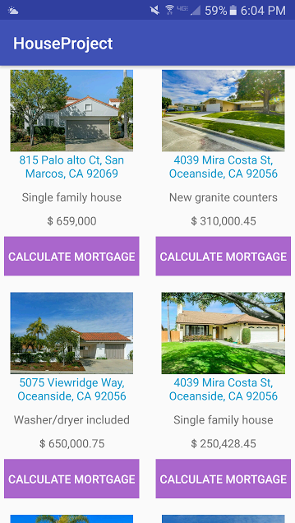

Using the Google Maps API, it opens up a web view of the map

Using an explicit Intent, it switches to *MortgageCalculator* activity

Clicking this section opens up the *RatingActivity* using an explicit Intent

Using an explicit Intent, we call the *ImageGallery* activity

**Note**: More screenshots of the app are located under the *screenshots/* folder.